EXERCISE NO. :

MODELLING OF A POSITION CONTROLLED PLANAR MECHANISM METHOD 1

DATE:

Reg. No. :

**LAB PREREQUISITES:**

Introduction to Physical Modelling

**PREREQUISITE KNOWLEDGE:**

Fundamentals of SIMULINK modelling of physical systems.

**OBJECTIVES:**

* + To model a one degree of freedom joint constituting a planar mechanism using the Foundation Library in Simscape.
  + Understand the dynamics of the mechanism for an applied torque by the actuating element.
  + To add a controller to the actuator connected to the mechanism and observe the controlled behavior.

**THEORY**

**Dynamics of the Mechanism**

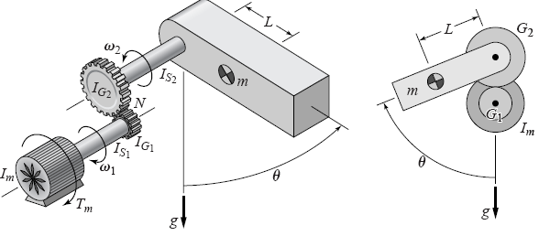

|  |  |
| --- | --- |
| **Physical Parameter** | **Specification** |
| Moment of inertia of the drive shaft, I­S1 | kg $·m^{2}$ |
| Moment of inertia of the driven shaft, IS2 | kg $·m^{2}$ |
| Gear ratio | 2 |
| Mass | 4 kg |
| Length of the link | 0.25 m |
| Acceleration due to gravity | 9.81 m/s2 |

**Modelling Gravitational Torque**

The torque acting on the link due to gravity may be modelled as

– m.g.L.sinθ

**Model of a DC Motor**

To add actuator to the actuated link model use the following parameters.

|  |  |
| --- | --- |
| **Physical Parameter** | **Specification** |
| Armature resistance | 0.5 Ohm |
| Electrical inductance | 0.002 H |
| Torque Constant | 0.05 Nm/A |
| Motor Inertia | 9× 10-5 kg·m2 |
| Maximum Voltage | 10V |

**EXERCISE TASKS**

**Task 1**

* Model a one DoF planar mechanism shown in the figure. Use the Ideal Torque Source for the gravitational torque component.
* Model the gearbox with only the gear ratio neglecting the gear friction.
* Use signal builder to generate a torque profile as shown below:

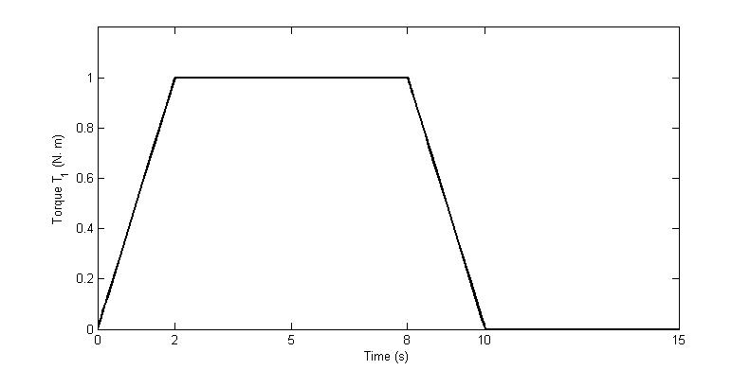

* Use Simscape🡪Foundation Library🡪Physical Signals🡪Functions library 🡪PS Math Function to model the parameters for the gravitational torque component.
* After modelling, simulate the model for 15 seconds. Plot the angular position of the joint.
* Observe the constant amplitude oscillations for time < 10 seconds. Observe the link’s oscillations like a pendulum after the applied torque is made to zero after 10 seconds.

**Task 2**

* The objective of the task is to develop a feedback control in angular position.
* Neglecting the circuit dynamics add a PID controller to the model. Set the values as Proportional, Integral, and Derivative based on tuning. Choose the values by properly selecting the desired response characteristics.
* Observe the control torque (the torque required to achieve the desired performance). *Note the controller gains may be found using tools from Mathworks like pidtool or sisotool or Simulink Control Design. The details of the algorithm used for tuning is not a part of this exercise.*
* Note the maximum torque required and the rate of variation of torque.
* At this point the engineer may want to consider including **the motor circuit model** in order to determine the maximum required current.

Note the benefit of Model-Based Design: It is possible to evaluate alternatives and make informed design decisions well in advance of hardware implementation and testing.

**Task 3 (Practice exercise)**

* Replace the Ideal Torque Source used for the joint actuation by a DC Motor model with the suitable specifications given in the table.
* Plot the angular velocity and observe the period of oscillation for non-zero value of applied torque.
* Compare the oscillations for the Ideal Torque Source with DC Motor model.
* Plot the armature current.

**DELIVERABLES**

**Task 1**

* Plot of Position vs. Time under no load condition for the torque profile.
* Write the reason for the constant amplitude oscillations for t<10 seconds.
* Write the period of oscillations after t = 10 seconds.

**Task 2**

* Write the values of P, I, D gains after tuning.
* Plot the control torque vs. time.
* From the graph write down the maximum torque required.
* Plot the desired angular position and actual angular position.
* Plot the armature current vs. time.
* Comment on the transients required for the torque and current and what implications do it has on the system design.

**Task 3**

* Inclusion of dynamics of DC motor to the existing model replacing the ideal torque source
* Plot the Velocity vs. Time
* Compare the oscillations obtained in this case with Ideal torque source used in Task1.